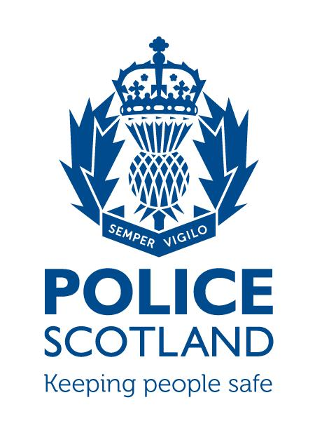

Tayside Division

Angus LPA

LPA Commander - Chief Inspector David McIntosh

LOCAL COMMUNITY POLICING AREA REPORT

Local Community Policing Area | Montrose and District:  TaysideMontroseDistrictCPT@Scotland.pnn.police.uk  Brechin and Edzell:  TaysideBrechinEdzellCPT@Scotland.pnn.police.uk
Local Area Inspector | Inspector Alice Coventry alice.coventry@scotland.pnn.police.uk)
Local Community Policing Team | Sergeant Clark Renilson (clark.renilson@scotland.pnn.police.uk)  Constable Ally Hutchison (alistair.hutchison@scotland.pnn.police.uk)  Constable Paul Conboy (paul.conboy@scotland.pnn.police.uk)

To be sent to the following Community Council email addresses on the 21st of each month outlining the previous month’s activity.

City of Brechin and District CC - eric.gray768@btinternet.com
Ferryden and Craig CC – gordoncbrown@talktalk.net - Chairman
gordie48@sky.com - Sec
Hillside, Dun and Logie Pert CC – teenrussell@yahoo.co.uk
Inveresk CC – wilson.claire@hotmail.co.uk
Montrose CC- ruttom26@aol.com
Communities – reidh@angus.gov.uk

PART A
NATIONAL AND LOCAL CAMPAIGNS AND MESSAGES
HATE CRIME
With over 300 Third Party Reporting Sites across the country, hate crime is a priority for Police Scotland and the campaign seeks to reinforce the message that prejudice based on sexual orientation, transgender identity, disability, racial or religious lines will not be tolerated.
As victims don’t always think a crime has been committed or thinking that ignoring the issue will make it go away, hate crime has become a widely unreported problem in Scotland. The campaign aims to provide a greater understanding to the public about what constitutes hate crime and how it can be reported.
Hate crime is defined as a crime perceived as being motivated by malice or ill will towards a particular social group on the basis of their actual or presumed sexual orientation, transgender identity, disability, race or religion.
Individuals who think targeting people who are different to them is acceptable behaviour are being forced to think again. Police Scotland is working with partner organisations to end such activity and bring perpetrators to justice.
Reports can be made by calling 101, via the Police Scotland website or at any third party reporting site, all of which are again found on the Police Scotland website.
TERRORISM

Following the horrific incident in Manchester the threat level nationally has been raised to CRITICAL.
Although there is no specific intelligence regarding a threat to Scotland, we have put in place measures to maximise security and to provide reassurance to the general public.

In Brechin and Montrose, high profile uniformed patrols will be carried out.
Any person with any concerns should report these through the non-emergency 101 number.

PROPERTY

Now that the lighter nights are with us and the weather is warming up, there is a tendency amongst us to become complacent when it comes to home security and the security of our belongings.

Criminals are opportunists and will take advantage of any complacency shown.

- We would recommend locking doors and windows when out of the home
- when at home ensure that doors and windows are not left fully open where they are out of you sight
- many items of garden furniture are expensive – try to lock them away or secure them overnight and keep an eye on them during the day.
- Items such as kids and adult bikes are often the target of theft as they are easily removed. Do not leave these lying in gardens unattended. Also consider having cycles and other similar items security marked.
- Cars and garages/sheds are often overlooked and left unlocked. Again thieves find these easy targets. Simple advice of locking cars sheds and garages can save you becoming the victim of crime. Consider purchasing a shed alarm which would assist in safeguarding your property.

POLICE SURGERIES

The new community policing team are still looking to increase police surgeries in both Montrose/Brechin and Edzell. Dates/times and locations will be advertised via social media and in the local press. This allows the public the opportunity to speak to their local community officers face to face and discuss any issues that they feel the police could assist with.

Recent crimes/issues in the area:
Brechin and District

During the period from 21/04/2017 – 21/05/2017 there has been 51 crimes reported in the Brechin area which cover a variety of incidents including in these numbers are Vandalisms/Theft/Assault/Disorder/Drugs and Road Traffic Offences.
Of the 51 reported crimes, 24 have thus far been detected with the others still under investigation

Montrose and District

During the same period in Montrose and District there has been 78 crimes reported, of which 47 have been detected with other still under investigation. Again these incidents vary in content and follow the same pattern as Brechin.

Road policing issues locally:
Parking offences have now been decriminalised and are the responsibility of the local authority. Angus Council staff have been trained and are now carrying out enforcing throughout Angus.

Police Scotland will continue to enforce school ‘Keep Clear’ markings until a new legal order is in place. The order is expected to be in place by the end of July 2017.
Where decriminalisation has been implemented offences are subject to a civil penalty notice. Police Officers will no longer have powers to take enforcement action against vehicles parked in contravention of yellow lines (single or double), timed parking restrictions, loading bays, disabled parking bays or areas of ‘pay and display’ parking.
Under these conditions Police Officers will still be responsible for offences covered by fixed penalty notices including dangerous parking, obstruction and stopping within the controlled area of pedestrian crossings, even when these offences are committed in areas patrolled by Parking Attendants

Local initiatives:
The local community policing team in Montrose have been working with the primary schools to provide advice and guidance relating to road safety matters outside the schools. This consists of working with the heads and pupils who will monitor incidents relating to parking offences in restricted areas. This has been expanded to Brechin and has been used to good effect at all participating schools.

Forthcoming events in area (associated issues):
MOFEST – Fri 26/5/17 – Sun 28/5/17

MOFEST brings a series of policing challenges, mainly in relation to the increased number of visitors to the town, high levels of alcohol consumption and the associated disorder this brings. Additional officers will be on duty to ensure the safety of those in attendance.
All local legal orders remain in place in relation to the consumption of alcohol in public places and these offences will be dealt with in a variety of ways.

BRECHIN PAGEANT Sat 03/6/17

Local officers will give appropriate attention through the course of the day.

ANGUS SHOW Sat 10/6/17

Again officers will be in attendance at the yearly event.

Other topics of note or messages:
COMMUNITY POLICING TEAM

Inspector Alice Coventry: alice.coventry@scotland.pnn.police.uk
Sergeant Clark Renilson: clark.renilson@scotland.pnn.police.uk
Constable Alastair Hutchison: alastair.hutchison@scotland.pnn.police.uk
Constable Paul Conboy: paul.conboy@scotland.pnn.police.uk

As the community policing team develops it is the intention to hold regular police surgeries in Montrose and Brechin which will be advertised in the local presss and via social media. We would like to encourage the local community to either attend or if they are not in a position to do so please feel free to use the contact email details provided above regarding any community issues.

PART B
Feedback from Community Council
(Issues raised worthy of police interest for feedback)
 | Issue of police interest raised | Raised by
1
2
3
4
5
6

7

8

PLEASE RETURN THIS FORM – to Local Community Policing Team

