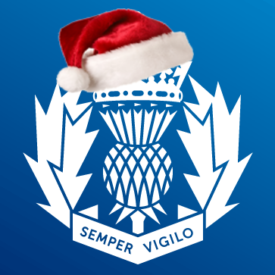

Tayside Division

Angus LPA

LPA Commander - Chief Inspector David McIntosh

LOCAL COMMUNITY POLICING AREA REPORT

Local Community Policing Area | Montrose and District  Brechin and Edzell
Local Area Inspector | Inspector Alice Coventry (In post January 11th)
Local Community Policing Team | Sergeant Clark Renilson (clark.renilson@scotland.pnn.police.uk)  Constable Ally Hutchison (alistair.hutchison@scotland.pnn.police.uk)  Constable Paul Conboy (paul.conboy@scotland.pnn.police.uk)

To be sent to the following Community Council email addresses on the 21st of each month outlining the previous month’s activity.

City of Brechin and District CC - eric@brechincommunitycouncil.org.uk
Ferryden and Craig CC – gordoncbrown@talktalk.net
Hillside, Dun and Logie Pert CC – teenrussell@yahoo.co.uk
Inveresk CC – wilson.claire@hotmail.co.uk
Montrose CC- ruttom26@aol.com

PART A
NATIONAL AND LOCAL CAMPAIGNS AND MESSAGES
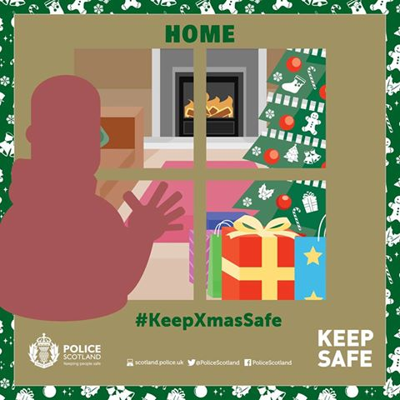

Secure your home this Christmas....
- Lock all windows and doors, don’t leave gifts in view of the windows and keep cash in your home to a minimum.
- If you’re going away for Christmas or New Year, set your house alarm if you have one, use timers on lights, cancel any deliveries and ask a neighbour or friend you trust to keep an eye out while you’re away.
- If you’re having a house party with lots of guests, make sure you know everyone who is there. If you’re going to a party, don’t let anyone tailgate you into a house or through a secured communal entry door who may not be a guest.

Recent crimes/issues in the area:
Brechin

28/11 - Stoneyford Birches, Hunthill Estate, Glen Lethnot – Theft of snare.
1/12 – Eastbank, Brechin – Vandalism – Smash window.
9/12 – River Street, Brechin – Theft of pedal cycle from shed.
09/12 – Castle Street, Brechin – Theft of pedal cycle from shed.
17/12 – Brechin Car Company, Montrose Road, Brachin – Theft by housebreaking.

Montrose and District

22/11 – Lower Balmain Street, Montrose – Vandalism – Scratch car.
28/11 – Osprey Road, Montrose – Theft by housebreaking
17/12 – Bents Road, Montrose – Vandalism – Slash tyre of car.

Road policing issues locally:
Community officers in Angus carried out a road safety initiative at Glamis and Eassie primary schools on Friday 9 December to educate drivers on the dangers of speeding in and around schools.
The officers received assistance from children from the primary schools, who were handing out leaflets to motorists to make them aware of the dangers of driving at speed and the consequences of this.
Drivers should always reduce their speeds in response to where they are and what is around them. This is never more important than when they are on roads where children are making their way to or from school.
All pupils and parents should ensure they cross with care. Responsible behaviour on everyone’s part can help make sure that avoidable accidents, and the trauma and heartbreak that goes with them, are avoided.

Local initiatives:
Since 5th December 2016, Angus Community Constables Mark Reid and Paul Morgan have been delivering training to pupils at Forfar Academy on violence and disorder prevention using the national football-related PITCHIN' IN programme.
The 13 pupils involved have received training in respect of 4 main areas;
What is offending?
Why get involved?
What are the consequences of offending?
What is the language of offending?
In addition, local Fire Service Watch Manager Dave McKenzie also delivered a session to the pupils on the illegal use of pyrotechnics at football matches along with fire safety awareness training. This has proved to be a very successful piece of inter-agency work with fantastic contributions from the pupils involved.

Forthcoming events in area (associated issues):
None at present

Other topics of note or messages:
On 11th January, 2016, the new Local Community Policing Team in Angus will change and increase in size. This will mean an increase in dedicated Community Officers who will be visible in the community tackling local issues. Each area will have a new Locality Inspector, Sergeant and team of officers. The officers and each of their contact details will be listed on the monthly reports. It will be the responsibility of each of the Sergeants to continue sending the reports on a monthly basis on the 21st. With more Sergeants completing these, each month there should be more detail on the reports.

The teams are as follows.

Forfar, Kirriemuir and District
Inspector Stephen Main, Sergeant Colin Echevarria, Constables Scott Anderson, Barrie Taylor and Gail Beattie.

Montrose, Brechin, Edzell and District
Inspector Alice Coventry, Sergeant Clark Renilson, Constables Ally Hutchison and Paul Conboy.

Arbroath and District
Inspector Gary Aitken, Sergeant Grace Ewing, Constables David Voigt, Darren Burnett and Suzanne Stark.

Monifieth, Carnoustie and District
Inspector Gary Aitken, Sergeant Shaun McQuade, Constables Steve Wilson and Fiona Allardice.

PART B
Feedback from Community Council
(Issues raised worthy of police interest for feedback)
 | Issue of police interest raised | Raised by
1
2
3
4
5
6

7

8

PLEASE RETURN THIS FORM – to Local Community Policing Team

