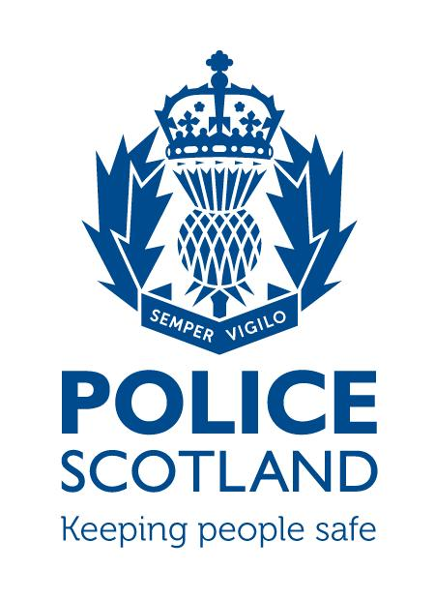

Tayside Division

Angus LPA

LPA Commander - Chief Inspector David McIntosh

LOCAL COMMUNITY POLICING AREA REPORT

Local Community Policing Area | Montrose and District:  TaysideMontroseDistrictCPT@Scotland.pnn.police.uk  Brechin and Edzell:  TaysideBrechinEdzellCPT@Scotland.pnn.police.uk
Local Area Inspector | Inspector Alice Coventry alice.coventry@scotland.pnn.police.uk)
Local Community Policing Team | Sergeant Clark Renilson (clark.renilson@scotland.pnn.police.uk)  Constable Ally Hutchison (alistair.hutchison@scotland.pnn.police.uk)  Constable Paul Conboy (paul.conboy@scotland.pnn.police.uk)  Constable Billy Rattray (billy.rattray@scotland.pnn.police.uk)

To be sent to the following Community Council email addresses on the 21st of each month outlining the previous month’s activity.

City of Brechin and District CC - eric.gray768@btinternet.com
Ferryden and Craig CC – gordoncbrown@talktalk.net - Chairman
gordie48@sky.com - Sec
Hillside, Dun and Logie Pert CC – teenrussell@yahoo.co.uk
Inveresk CC – wilson.claire@hotmail.co.uk
Montrose CC- ruttom26@aol.com

PART A
NATIONAL AND LOCAL CAMPAIGNS AND MESSAGES
DRIVING WHIST USING A MOBILE PHONE/HANDHELD DEVICES

At 00:01hrs on Wednesday 1 March Regulation 110 of the Road Vehicles (Construction and Use) Regulations 1986 will be amended to increase the fixed penalty fine levels for road traffic offences involving the use of mobile phone and handheld devices.

This remains an endorsable offence and from the above date it will attract an increased penalty of 6 points and a £200 fine.

BOGUS CALLERS

There has been an increase in bogus callers in Scotland with an elderly couple in Montrose being targetted in the last week. These callers are presenting themselves as legitimate contractors who are offering to carry out work for the householder resulting in sub standard work some of which is not required in exchange for a costly bill. The more elderly and vulnerable in our communities are the main targets and it is important that we remain vigilant to such approaches. It might be a neighbour/friend or a family member so the message is to contact Police Scotland via 101 if any suspicions arise.

POLICE SURGERIES

The new community policing team are looking to increase police surgeries in both Montrose/Brechin and Edzell. Dates/times and locations will be advertised via social media and in the local press. This allows the public the opportunity to speak to their local community officers face to face and discuss any issues that they feel the police could assist with.

Recent crimes/issues in the area:
Brechin and District

During the period from 24/02/2017 – 24/03/2017 there has been 79 crimes reported in the Brechin area which cover a variety of incident which is on average just over 2 per day. Included in these numbers are Vandalisms/Theft/Assault/Disorder/Drugs and Road Traffic Offences. With the A90 on Brechins doorstep the majority of these road traffic incidents are speeding offences and cover approx 40% of the total number.

There are no major issues relating to crime trends or patterns but there are still a small number of incidents relating to the persons entering sheds/garages overnight with the message being to make sure that all outbuildings are secure and items locked away.

Several reports were received in the Wards Road area of Brechin relating to persons riding motorcycles off road. With the assistance of the public the persons involved in these activities have been identified and dealt with.

Montrose and District

During the same period in Montrose and District there has been 69 crimes reported which is an average of just over 2 per day. Again these incidents vary in content and follow the same pattern as Brechin.

A the light nights are slowly creeping in there is still an issue with a number of Youth related calls within John Street/Orange Lane/Murray Street/High Street being identified as the problem areas. These issues are being monitored with regular patrols being carried out in conjunction with engagement which is a key element to policing within the community.

With the annual MOFEST event only a few months away the police will be visiting local licensed premises to review their plans for the event and to reiterate what is expected from them in line with legislation and the management of premises with the intention to work together to make sure the event is once again a success.

Road policing issues locally:
Parking offences: There is still an issue in the towns relating to vehicles being parked illegally. It is the intention of the new community policing team to carry out enforcement in an attempt to identify and deal with the persons involved and to aid the free flow of traffic and improve road safety.

In the near future there will be assistance provided by the local community wardens who are employed by the council and will be in the process of undergoing training with a date for deployment to be announced in the near future.

Local initiatives:
As detailed in the previous report11/01/2017 saw the launch of the community policing model in Angus. The return to community policing will provide more officers on the street and allow for specific issues relating to their relevant community to be dealt with by identified officers. As part of this reform an Inspector has been posted to Montrose and will be responsible for all local policing matters within Montrose/Brechin and District. This Inspector will be aided by a Community Sergeant who in turn will be assisted by 3 Community Constables. The officers who will be carrying out this role are:

Inspector Alice Coventry: alice.coventry@scotland.pnn.police.uk
Sergeant Clark Renilson: clark.renilson@scotland.pnn.police.uk
Constable Alastair Hutchison: alastair.hutchison@scotland.pnn.police.uk
Constable Paul Conboy: paul.conboy@scotland.pnn.police.uk
Constable Billy Rattray: william.rattray@scotland.pnn.police.uk

As the community policing team develops it is the intention to hold regular police surgeries in Montrose and Brechin which will be advertised in the local presss and via social media. We would like to encourage the local community to either attend or if they are not in a position to do so please feel free to use the contact email details provided above regarding any community issues.

Forthcoming events in area (associated issues):
None at present

Other topics of note or messages:

PART B
Feedback from Community Council
(Issues raised worthy of police interest for feedback)
 | Issue of police interest raised | Raised by
1
2
3
4
5
6

7

8

PLEASE RETURN THIS FORM – to Local Community Policing Team

